**TABLE OF CONTENTS**

LIST OF FIGURES ii

INTRODUCTION 1

OBJECTIVE 2

PROGRAM AND DESCRIPTION 3

PROGRAM DESIGN 5

DISCUSSION 10

CONCLUSION 11

REFERENCES 12

# LIST OF FIGURES

Figure 1: Flowchart. Page 3

Figure 2: Roasting process. Page 5

Figure 3: Winnowing Process Page 5

Figure 4: Conveyor process. Page 6

Figure 5: Blending process Page 6

Figure 6 subVI Page 7

Figure 7: Event report generation. Page 7

Figure 8: Sugar price Page 8

Figure 9: Web publishing tool. Page 8

Figure 10: Designed system. Page 9

Figure 11: Designed system (After execution). Page 9

# INTRODUCTION

Chocolate processing system uses several tools and techniques to make the cocoa seeds into product ready chocolate. This type of system is almost like all of the chocolate processing system, system is designed using the same old technique of processing cocoa but replace it with machines, which makes the overall production faster and efficient. There are certain steps for designing this type of system: -

**Roasting and winnowing**: - The roasting process causes the cocoa shells to become brittle, and the cocoa nibs to run through a succession of sieves that strain and sift the nibs according to size in a process known as "winnowing."

**Grinding and Mixing**: The grinding process creates heat, and the dry granular nature of the cocoa nib is subsequently transformed into a liquid when the nib's high fat content melts. Cocoa liquor, cocoa butter, and sugar are combined.

**Blending Cocoa liquor and moulding Chocolate**: After the mixing procedure is completed, the blend is refined further to reduce the particle size of the additional milk and sugar to the necessary fineness for consumption. After the blending process is complete, the final step in the chocolate production process is moulding. As a result of this procedure, the cocoa liquor might cool and harden into various forms depending on the mould used.

To control and automate the machines required in the processing system, companies use software which control the flow of the machine

The software used to design and simulate the automation process is LabVIEW. LabVIEW is a graphical programming environment that aids in the visualisation of all aspects of an application, including hardware configuration, measurement data, and debugging. This visualisation simplifies the integration of measuring gear from any vendor, the representation of complicated logic on the diagram, the development of data analysis algorithms, and the construction of specialised engineering user interfaces. LabVIEW provides a variety of tools and a simulation framework to help us construct the projects we want. (Instruments, 2018 )

# OBJECTIVE

* To simulate chocolate process management.
* To generate Event report.
* To monitor the process using web publishing tool.
* To display the sugar price using data socket read.

# PROGRAM AND DESCRIPTION

**FLOWCHART**

Figure 1: Flow chart.

The flow chart for the complete system is depicted in Figure 1. The roasting process is initiated by the programme, and a numerical thermometer is utilised to illustrate the roasting progress. The numerical thermometers begin at zero and grow by a predetermined amount on a regular basis. A custom control was created to illustrate the winnowing process, and the control was designed to animate for a specific amount of time during the process. During material transfer across systems, a conveyor custom control slider movement is presented to demonstrate how materials are transferred. To monitor the progress of the griding and mixing processes, Leds were employed to show how the processes were progressing. A mixing animation custom control has been provided to demonstrate the process of combining Cocoa butter and sugar together.

The random number generator is used to perform the blending process, and different types of blends are picked depending on a certain range of numbers. The cocoa liquor slider and the vanilla slider are used in the production of the dark chocolate mix. The cocoa liquor slider, the milk slider, and the vanilla slider are all used for the milk chocolate mix. The white chocolate blend is made up of milk sliders and vanilla sliders, which are both accomplished. Led is utilised in the Moulding process to signify the completion of each step, and a conveyor slider is used to display the finished product package. The write to spreadsheet function is used to run the event report creation block, and numerous variables were introduced as inputs for the spreadsheet during the development process. Sugar price update is accomplished through the use of data socket read, and the price of sugar is updated on a regular basis. Using a web publishing tool, a link was generated that allows to monitor the process from browser.

.

# PROGRAM DESIGN

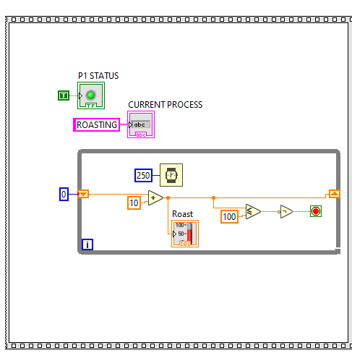

Figure 2:- Roasting process.

The roasting process is executed using a while loop, initial numeric constant 0 is initialized as one of the inputs to addition function and another numeric constant 10 is another input. The output of the addition function is passed to the temperature numerical indicator, and to the shift register which takes in the output and make it as input for the next iteration. To make the loop work until value of 100, less than equal function is used. The output of less than equal function is passed as an input to not function which in turn passed to while execution termination condition. A string constant “roasting” is initialized as input to current process indicator.

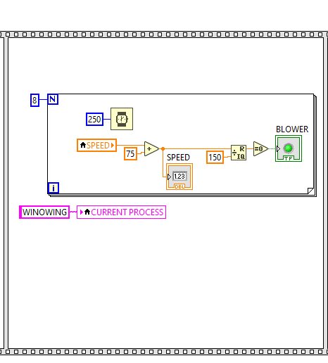

Figure 3: Winnowing Process.

Figure 3 shows the winnowing process algorithm, a for loop is used where numeric constant 8 is passed as input to loop count. This means that the loop will be executed for 8 times, a Wait ms function is used to wait for 250ms after every iteration. Speed variable and numeric constant 75 is passed as an input to addition function the output of the addition function is passed as input to Speed numeric indicator and Quotient and remainder function. Based on the output form quotient and remainder function the blower led turns on and off.

Figure 4: Conveyor process.

Figure 4 shows the conveyor process, a while loop is used which contains an addition function, numeric constants 0 and 2 is passed as an input to the addition function. The output of the addition function is passed as an input to Conveyor slider, the output is also compared with 10 using less and equal function. The output of the comparison operator function is passed to Not operator, the output of the not operator makes the condition of the loop. If the output is true, the while loop keeps iterating else stops. A shift register is use for generating an increment value every iteration as input to the addition function.

Figure 5: Blending process.

Figure 6 subVI.

Figure 5 shows the blending process, this process contains a subVI whose output is the input for case structures. Figure 6 shows the subVI process, a random number generator is used whose lower range is 0 and upper range is 10. The output of the random number generator is passed as an input to three In Range and Coerce function, each in range and coerce function has a lower and upper range. The output of the in range and coerce function is passed to build array function, the output of the build array function is passed as an input to search 1D array this function looks for the True condition in the build array and returns the index of the true element. Since there are three index number which can be generated hence a case structure with 3 cases is initialized.

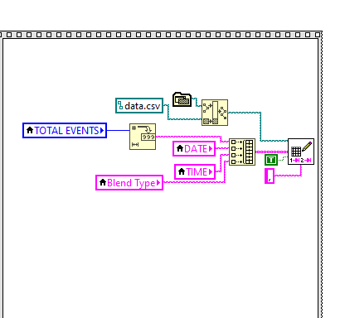

Figure 7: Event report generation.

Figure 7 shows the event report generation, four local variables are used as an input to build array. Since the array can only hold one type of data hence, the total event variable data which is a numeric type is passed to number to string function. The build array generates a one-dimensional array, this array is passed as an input to write spreadsheet function. Another input for write spreadsheet function is the append to new file for which a true constant is passed, this makes sure that every time a new program starts the previous data won’t be deleted and the new data will be appended. For the delimiter input a comma key constant is provided as an input since the type of file is csv file. A build path function is used as an input to file path input of write spreadsheet function, build path function generates a file path after getting two input one is the file directory and another is file name. For file directory application vi directory function is used, this function generates the current directory where the LabVIEW project file is located.

Figure 8: Sugar price

Figure 12 shows the block diagram used to obtain Sugar.“It is necessary to use the Data Socket Read function. To establish the value of a price, we must first eliminate all of the information that exists before and after that precise number, in this case, the price of sugar price. In order to do this, two 'Match Patterns' have been employed, the first of which is used to integrate the website information obtained through a data socket, and the second of which is used to connect the first match pattern to the 'Scan from string' which turns the data into a number. It is subsequently transferred to an array and shown on the front panel of the program.” 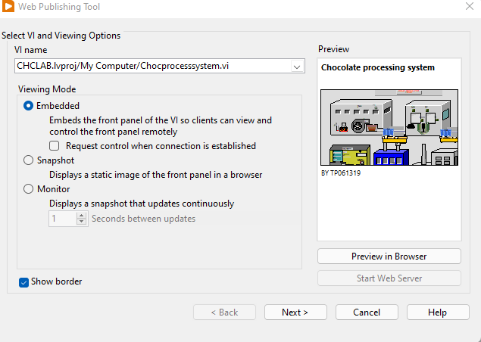 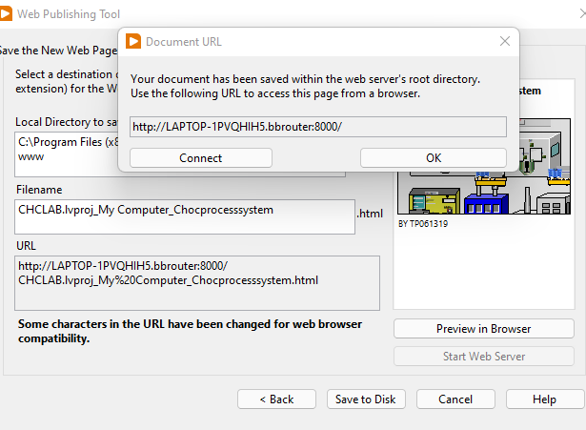

Figure 9: Web publishing tool.

The VI is published on a server using a web publishing tool, which can then be seen and maintained from any location in the globe using a web browser. Web publishing makes use of three various sorts of possibilities, which are Embedded, Snapshot, and Monitor. For our assignment, the monitor choice with a refreshing rate of one second has been selected to provide speedier results and information presentation. This is critical in the majority of systems since it allows the user to keep track of the data in their system at any time they want. The online publishing tool that was utilized for the system is seen in Figure 9.

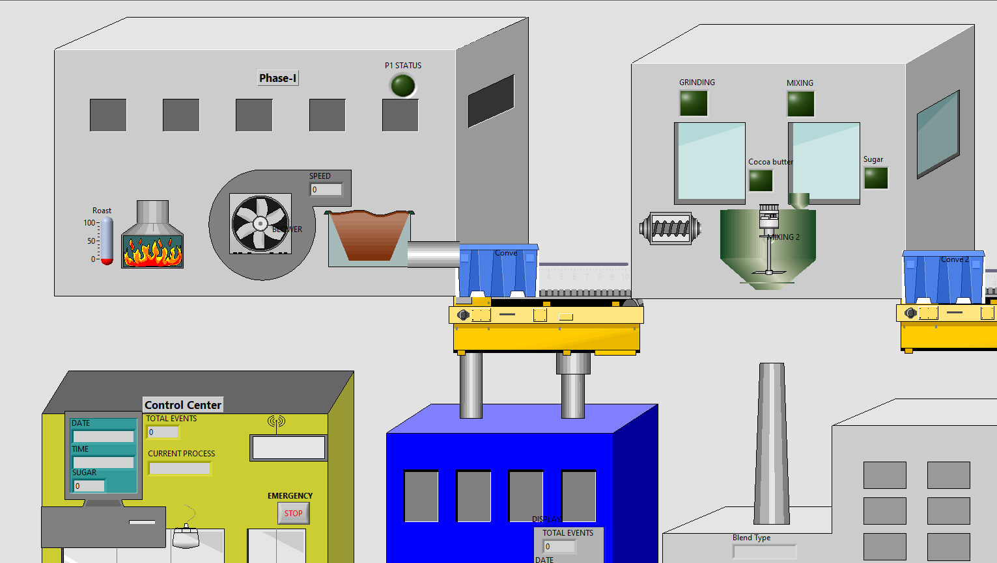

Figure 10: Designed system.

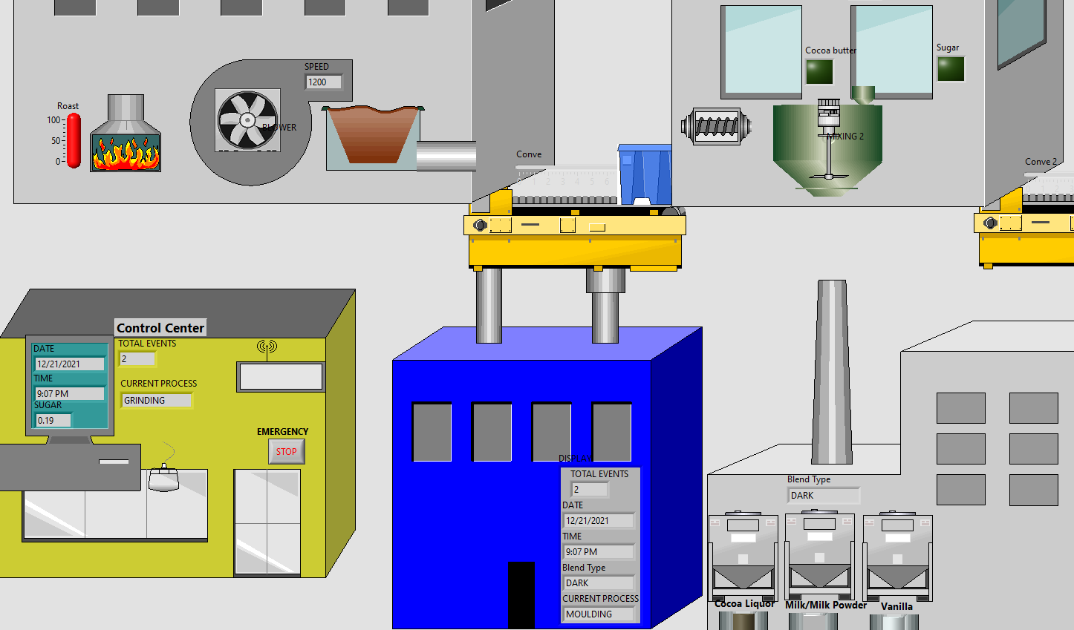

Figure 11: Designed system (After execution).

# DISCUSSION

Chocolate processing system includes several numerical, string, Boolean control, and cluster indicators. Custom control was designed using the numerical slider and Boolean indicator, the custom control uses image navigator of the DSC module. Local variable is also used to read and write the control on several occasions in the program. For loops were used when the executions need to be run for a specific number of times, while loop were used when the executions depend upon a condition.

Flat sequence structure is used in almost all instances, since this structure makes the structure runs in sequence which helps in tracking and controlling the flow of the program as required. Case structure was used during the requirement of several different cases for a specific task, for the blend type selection there were three different cases, and each case will have its unique block, hence a case structure was used to perform the blending operation.

Arrays and clusters were used when there was required to store multiple data in a single variable. While array was used when there was required of single data type such as during the implementation of event report, the write spreadsheet function requires 1d array as input. Clusters was used when there were multiple data types such as for displaying the information to ongoing facilities a cluster was used to display date, time, total number of events, current blend type, and current process.

The system also has a web publishing capability, which is quite handy for keeping track of a developed system from any location in the globe at any time. It is also feasible to give consumers with real-time values through the usage of the internet while using LabVIEW. For example, in the present project, it is necessary to have access to sugar pricing information in real time, which is readily accomplished by utilising the Data Socket Function. SubVI was used in the program, which is a section of the whole program, it helps in reduction of the blocks from the main Vi and makes the VI easier to track and understand.

# CONCLUSION

The assignment required certain objectives for the chocolate processing system. The designed system contains the roasting process, winnowing process, grinding process, mixing process, blending process, and moulding process. This process is implemented using several functionalities available in LabVIEW. Event report generation was implemented using the Write spreadsheet function, and four variables were written to the csv file. Process monitoring was implemented using the web publishing tool, and live sugar price was implemented using the data socked read functions. All the required parameters of the assignment were implemented such as flow chart, array and clusters, sub-Vis, Loops, write to file, data sockets. It can be concluded that the designed system achieves all the objectives required for the assignment.

# REFERENCES

Bitter, R., Mohiuddin, T., & Nawrocki, M. (2017). *LabVIEW™ Advanced Programming Techniques*. CRC press.

Jennings, R., & la Cueva, D. F. (2019). *LabVIEW Graphical Programming, Fifth Edition* (5th ed.). McGraw Hill.